College of Arts, Media and Technology
Gifted school 2023
Database Management System (DBMS) and Programming

Lab 4: SQL
- Use the Data Definition Language (DDL) to create tables with attributes of the given ER diagram.
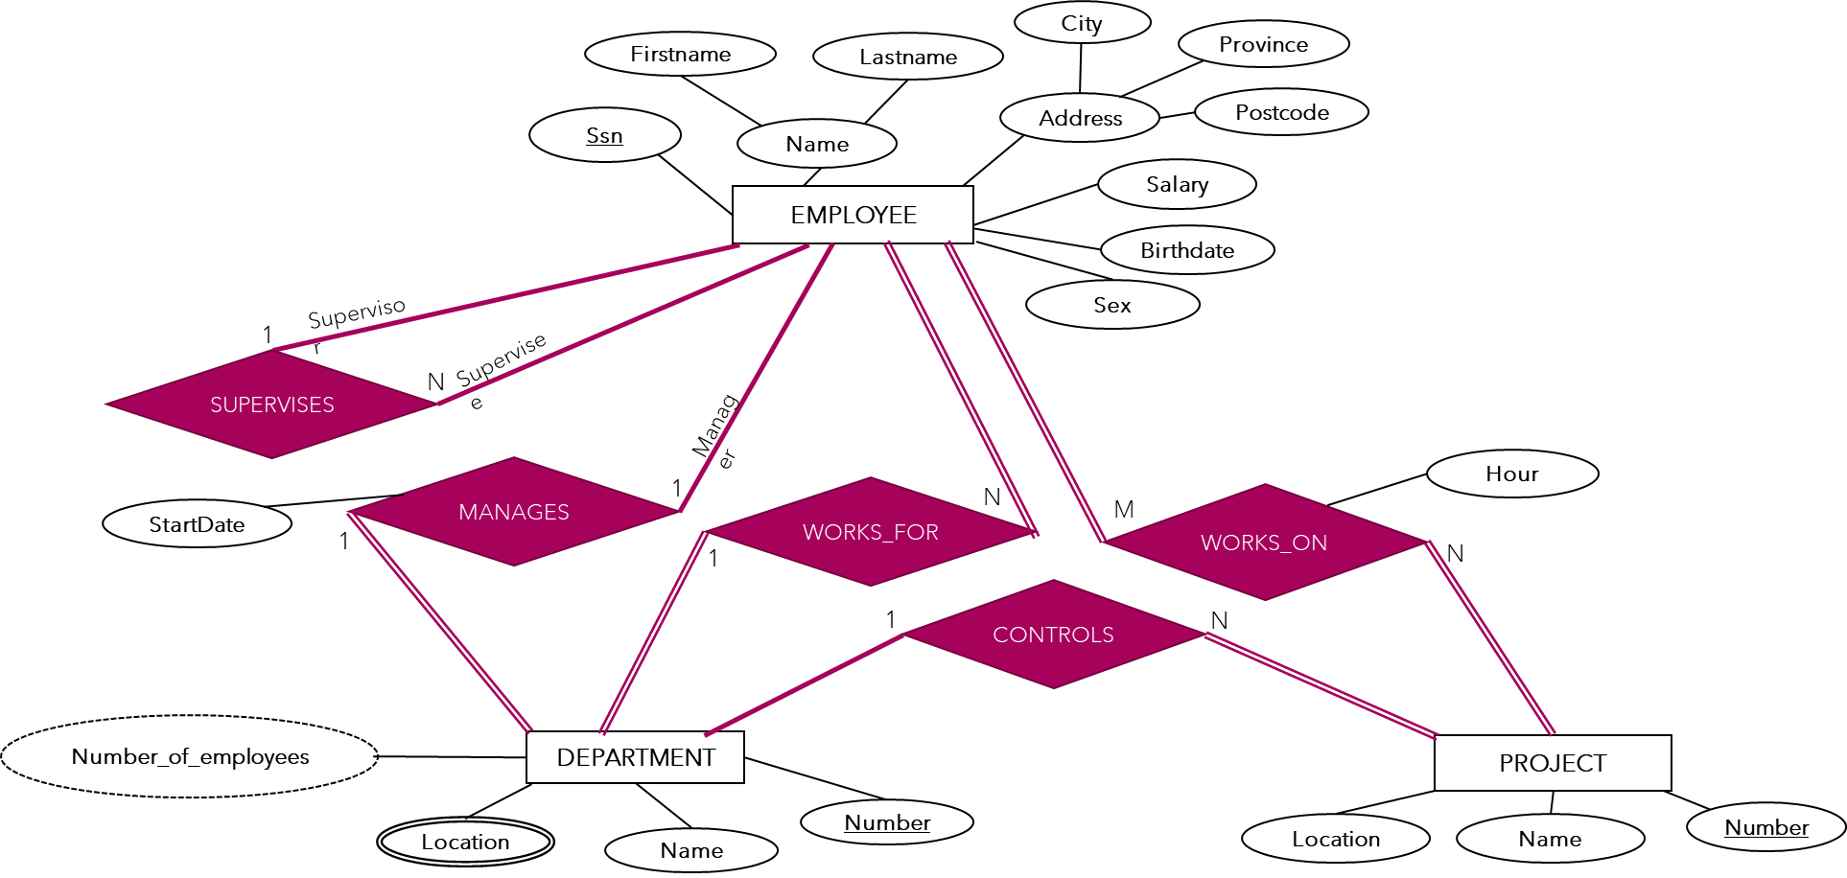
- Create the tables from question 1 and add the value by using SQL. (Snapshot each table with data).

- Use a given database to query the customer information which are first name, last name, country and email of whom stay in USA by Sqlite online

- Use a given database to query the customer information which are first name, last name, country and email of whom stay in USA, France and Brazil by Sqlite online

- Use a given database to query the customer information which are first name, last name and email who use the email with domain “@yahoo”
- Use a given database to query the album information of each artist

- Continue from question 6, join the tracks table to query the following information.
- Artist name
- Album title
- Track name
- Track milliseconds

